**Screen #2.5 During the game**

**Tone: Friendly :)**

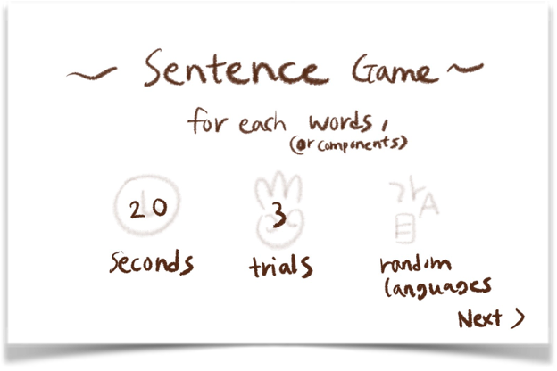

(The screen will be like this!!)

Notes:

* Same as the document before
* These are more difficult to translate for me as i never used certain words in hindi and always said it in english
* I used google translate A LOT (some words honestly I haven’t heard or used of, but I am sure some people would, those who speak the language in its pure form)
* And some words are just the hinglish versions, that is , the english word using hindi letters so it is based on the enunciation

For each word, (OR components) ☺ ***Your translation here: प्रत्येक शब्द के लिए***

Trials (OR CHANCES) ☺ ***Your translation here: ट्रायल्स (trials in hinglish..)/ अवसरों (chances)***

Seconds (AS TIME) ☺ ***Your translation here: सेकंड (just seconds in hinglish)***

Random Languages ☺ ***Your translation here: यादृच्छिक भाषाएँ***

___________________________________________

What do you think it means? (OR Can you guess it?)

☺ ***Your translation here: आपके विचार से इसका क्या आशय है?***

***क्या आप उत्तर का अनुमान लगा सकते हैं? (can you guess the answer?)***

Type… (AS A ‘TYPE HERE’)

☺ ***Your translation here: यहाँ टाइप करें (type here)***

You got it right!

☺ ***Your translation here: तुमने सही समझा!***

For the first trial, you wrote:

For the second trial, you wrote:

For the third trial, you wrote:

☺ ***Your translation here: पहले परीक्षण के लिए, आपने लिखा:***

***दूसरे परीक्षण के लिए, आपने लिखा:***

***तीसरे परीक्षण के लिए, आपने लिखा:***

The answer was ___ .

☺ ***Your translation here: उत्तर था _______***

next >>

(THIS IS A BUTTON FOR THE NEXT GAME)

☺ ***Your translation here: अगला***

You were so close!

(IF THE PLAYER DIDN’T GET THE ANSWER)

☺ ***Your translation here: आप इतने करीब थे!***

HOORAY!

You finished the game.

((OR)) That’s the end of the game.

(IT’S OKAY IF ‘HOORAY’ COULD NOT BE THE SAME IN YOUR LANGUAGE.

EXCITEMENTS LIKE ‘YEY!’ WOULD BE AWESOME.)

☺ ***Your translation here: हुर्रे!***

***आपने खेल समाप्त कर दिया।***

***Or***

***यह खेल का अंत है।***

Start Over >>

(RETURNING BUTTON)

☺ ***Your translation here: प्रारंभ करें***

***THATS ALL THANK YOU SO MUCH***